1. Prove the following theorem:
If two parallel lines are cut by a transversal, then the alternate exterior angles are congruent. (Alternate Exterior Angles Theorem)
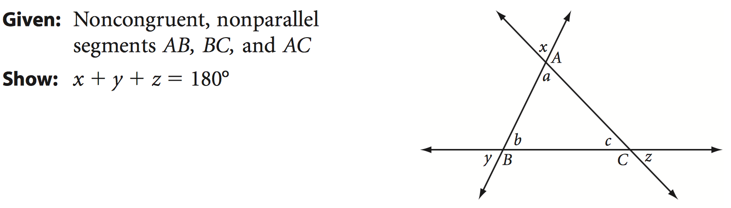
2.

1. Prove the following theorem:
If two parallel lines are cut by a transversal, then the alternate exterior angles are congruent. (Alternate Exterior Angles Theorem)
2.

1.Prove the following theorem:
If two parallel lines are cut by a transversal, then the alternate exterior angles are congruent. (Alternate Exterior Angles Theorem)
2.

