Geometry HW – Inscribed and Circumscribed Circles and Arc Length (Due 3/17)

- Sketch triangle ABC. Sketch an inscribed circle in △ABC. Sketch a circle that circumscribes △ABC. Do you think every triangle can have an inscribed and circumscribed circle?

- Sketch circle P. Sketch a circumscribed rectangle about circle P. Sketch a rectangle inscribed in circle P. What do you notice? Do you think this true for all rectangles?

- Determine if the following statement is true or false. If it is true, write a short explanation of your reasoning, including all the important geometric properties.
If a parallelogram is inscribed within a circle, then the parallelogram is a rectangle.
Given: Circle Y with inscribed parallelogram GOLD
Show: GOLD is a rectangle
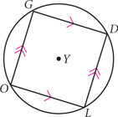

- Find the length of $\hat{CD}$.
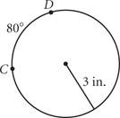
- Find the length of $\hat{BIG}$.
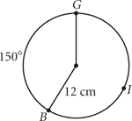
- The radius is 18 ft. Find the length of $\hat{RT}.$
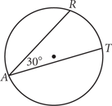
- The length of $\hat{AR}$ is 40$π$. $\overset{⃡}{CA}||\overset{⃡}{RE}.$Find the radius.

