Volume Homework: Real-World Context Problems Name: ________________________
Date: ______________ Block: ____

- Approximate the volume of a 12-foot tall tree trunk, in cubic feet, given the cross section shown.
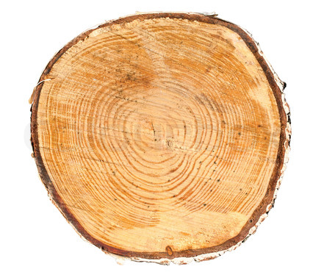
16”

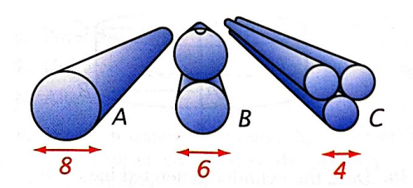
- Which arrangement of pipes would hold the most water?

- To answer this question, what would you assume about the pipes?

- Which arrangement is the correct answer?

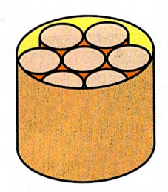
- Vienna sausages are sold in cans that contain seven sausages. The diameter of each sausage is 2cm and the diameter of the can is 6 cm. The sausages are 5 cm long and the can is 6 cm high.

Find the total volume in cubic centimeters of the seven sausages
  - as an exact number in terms of π
  - to the nearest integer.

Find the volume in cubic centimeters of the can
- as an exact number in terms of π
- to the nearest integer.

What percentage of the volume of the can do the sausages fill?
- Eight wooden spheres with radii 3 inches are packed snuggly into a square box 12 inches on each side. The remaining space is filled with packing peanuts. What is the volume occupied by the packing peanuts? What percentage of the volume of the box is filled with packing peanuts?

- The height of a cone is equal to three times the radius of the base. If the base has area 49π cm², what is the volume of the cone? Draw a picture to represent the situation.

- The radius of the Earth is about 6378 km and the radius of Mercury is about 2440 km. About how many times greater is the volume of Earth than that of Mercury? Show how you know in two different ways.

