8/15 Homework, due tomorrow

1) Name each line in two different ways. 2) Name each ray in two different ways.
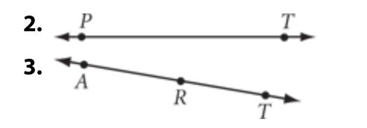

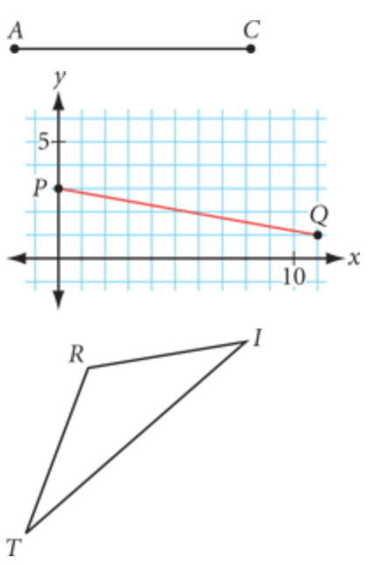
3) Name each line segment. 4a) Name each angle in three different ways.

4b) Draw and label each angle.
acute angle
obtuse angle
right angle

5) Parallel lines are lines that never ___________________.

6) When two lines intersect, they intersect at a ________________.

7) A circle is a continuous set of points all equal distance from a center point. This distance is called the ___________________.
r

