*HW due tomorrow, 8/11/16
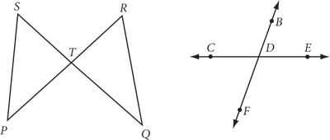
- For each figure at right, list the angles that you can name using only the vertex letter.

For 2-3, copy each figure and mark it with all the given information.
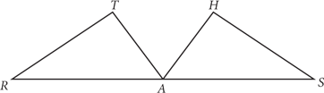
- RA = SA
m∠T = m∠H
RT = SH

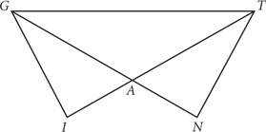

- AT = AG
AI = AN
∠AGT ≅ ∠ATG
GI = TN

For 4-5, write down what you know from the markings.
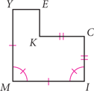
- MI = ?
IC =?
m∠M = ?

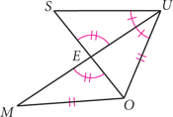
- ∠MEO ≅ ?
∠SUE ≅ ?
OU ≅ ?

