1)
Given: E is the midpoint of $\overline{BC} and ∠A ≅ ∠D$
A
B
E
D
C
Show: E is the midpoint of $\overline{BC}$

- E is the midpoint of $\overline{BC}$
- $\overline{BC} ≅ \overline{CE}$
- $∠BEA ≅ ∠CED$
- $∠A ≅ ∠D$
- $ΔABE ≅ ΔDCE$
- $\overline{AC} ≅ \overline{ED}$
- E is the midpoint of $\overline{AD}$

A
B
C
D
E

2)
Part 1:

What information would help prove $ΔABC ≅ ΔDEC by ASA?$ Choose all that apply.

A. Vertical angles are congruent B. C is the midpoint of $\overline{BE}$ C. $∠A ≅ ∠D$ D. $∠B ≅ ∠E$
Part 2:
What information would help prove $ΔABC≅ΔDEC by SAS?$ Choose all that apply.

A. C is the midpoint of $\overline{AD}$ B. $\overline{BC}≅\overline{EC}$ C. $∠B ≅ ∠E$ D. Vertical angles are congruent
Part 3:
Given $\overline{AB}≅\overline{DE} and \overline{AB}||\overline{DE}$, which triangle congruence can be used to show $ΔABC≅ ΔDEC$? Choose all that apply.

A. SAS B. AAS C. ASA D. HL E. None

3)
Given: NDOE is a parallelogram.

Part 1:
Choose all that apply to prove that parallelogram NDOE is a rectangle.
- $\overline{NO}≅\overline{DE}$
- $\overline{DN} ⊥\overline{NE}$
- $∠DNE ≅ ∠NDO$
M
- $\overline{NO} ⊥\overline{DE}$
- $∠MNE ≅ ∠NOE$
- $\overline{DO}≅\overline{OE}$
- $\overline{DM}≅ME and \overline{NM}≅\overline{MO}$

Part 2:

Given: Quadrilateral NDOE is a parallelogram; $m∠NEO ≅ m∠END$
Prove: Quadrilateral NDOE is a rectangle.

4)
$\overline{RT} and \overline{SU}$ are the diagnoals of a quadrilateral RSTU. The diagonals intersect at point M, so that $\overline{RM}≅\overline{TM}$ and $\overline{RS}$ is parallel to $\overline{TU}$. Is RSTU a parallelogram? Justify your reasoning.

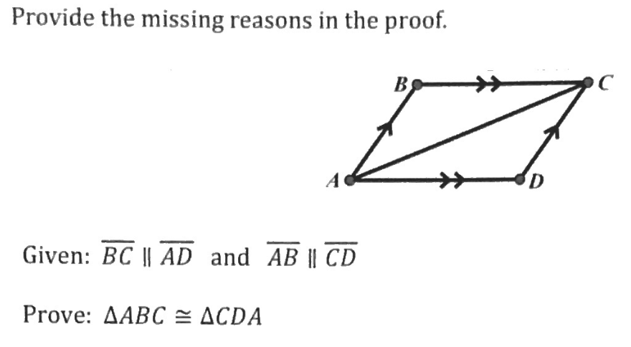
5)

